Micro-Assurances

Incident Response Runbook
Compromised Database Administrator Account

The objective of this runbook is to provide specific guidance on how to manage a compromised Database Administrator Account in the Micro-Assurance Amazon Web Services (AWS) environment.

This runbook focuses on the IR lifecycle:

• Establish Control
• Determine Impact
• Recover as Needed
• Investigate the Root Cause

Role | Control | Determine Impact | Recover | Investigate Root Cause
Database Administrator | Rotate database credentials, isolate DB instances | Identify which databases/data were accessed, check query logs | Restore from clean snapshots, rebuild DB instances | Analyze database logs for unauthorized queries, identify exploitation method
System Administrator | Isolate affected EC2 instances, apply security groups | Review system logs, identify compromised services | Restore from backups, patch vulnerabilities | Examine OS logs, identify persistence mechanisms
Network Engineer | Block malicious IPs, update firewall rules, isolate network segments | Analyze VPC flow logs, identify data exfiltration attempts | Restore network configurations, implement additional segmentation | Review network traffic patterns, identify C2 communications
Application Owner | Temporarily disable affected application features | Identify which customer data was exposed, notify affected users | Deploy patched application version, verify functionality | Review application logs, identify exploited vulnerabilities
Security Analyst | Coordinate response efforts, document findings | Assess scope of breach, determine data sensitivity | Verify security controls are working, conduct post-incident review | Perform root cause analysis, create timeline of events
Incident Responder | Lead containment efforts, communicate with stakeholders | Coordinate impact assessment across teams | Ensure business continuity, validate recovery | Document lessons learned, update runbooks

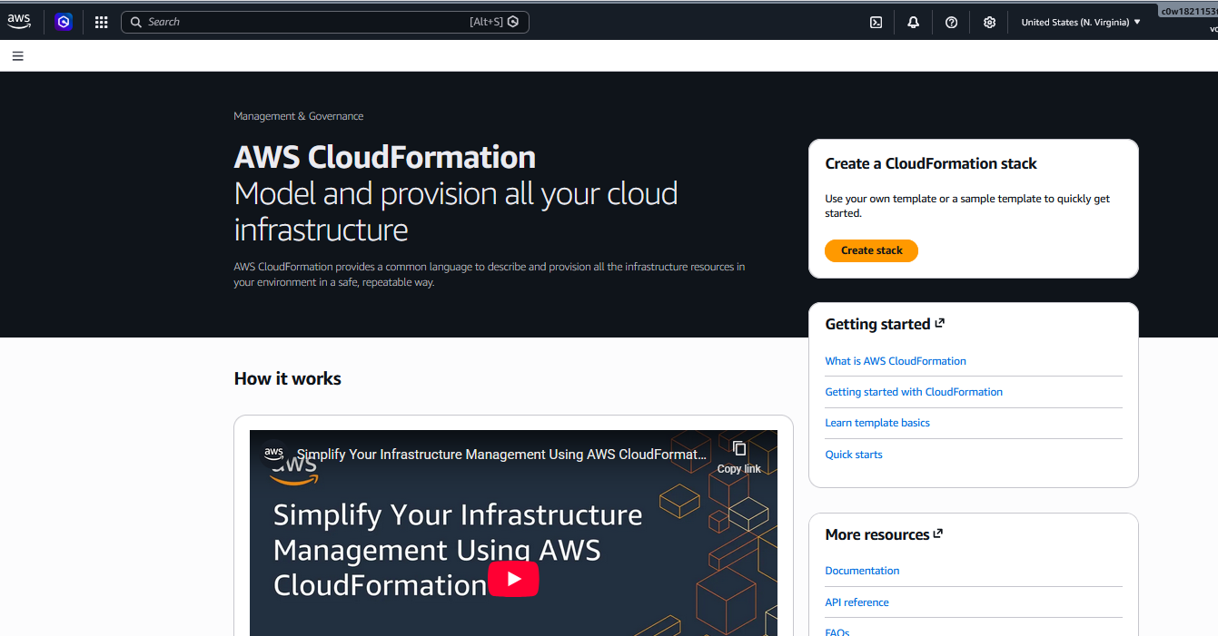
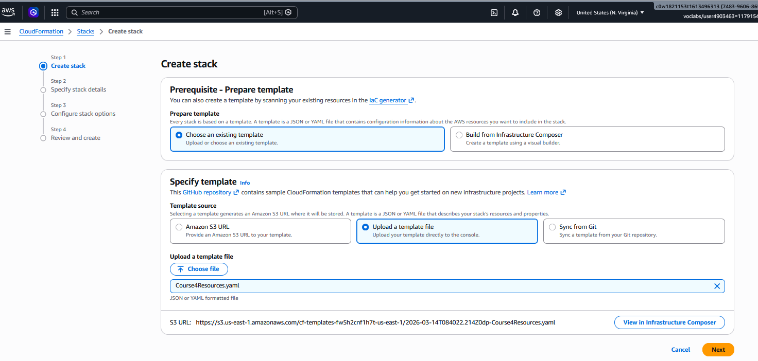
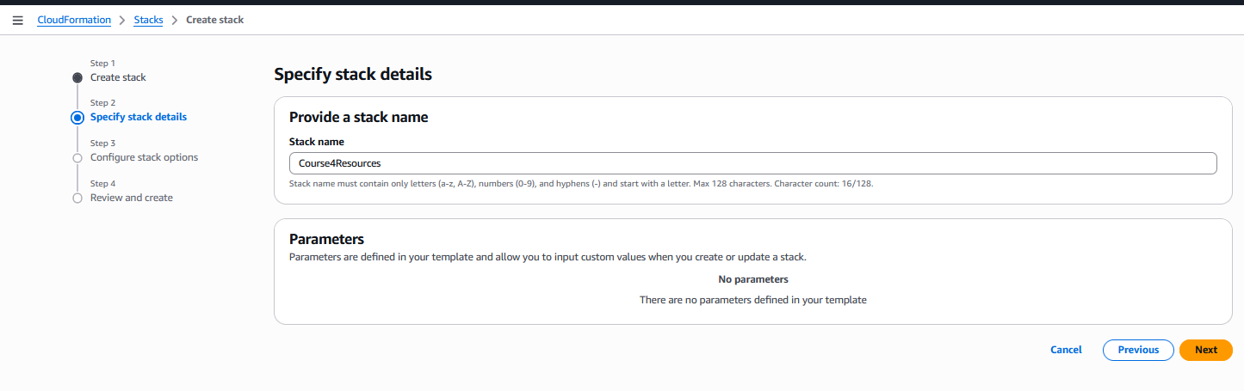
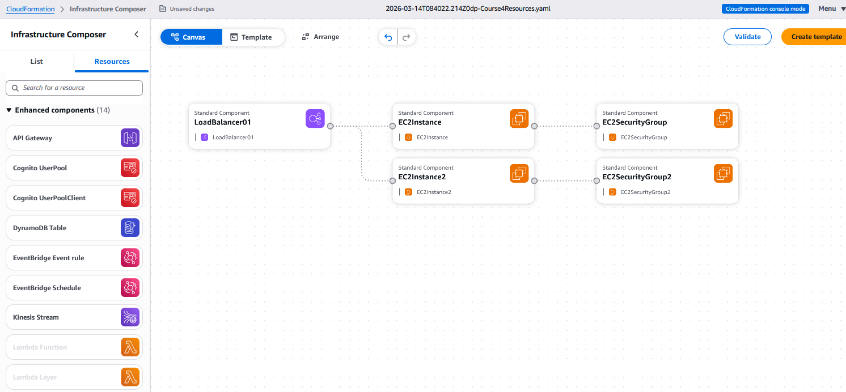
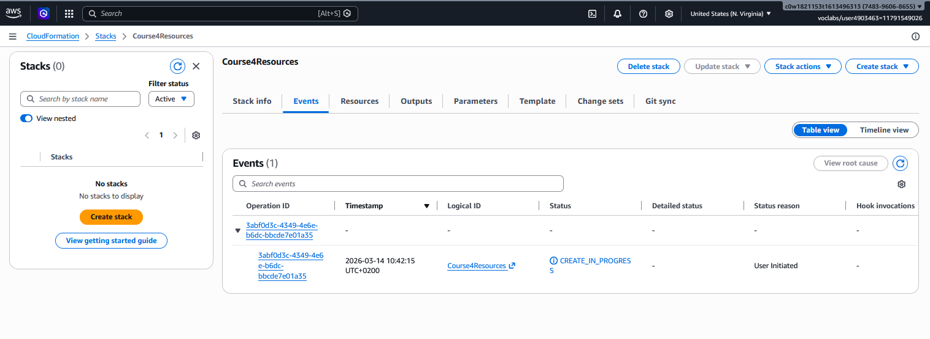
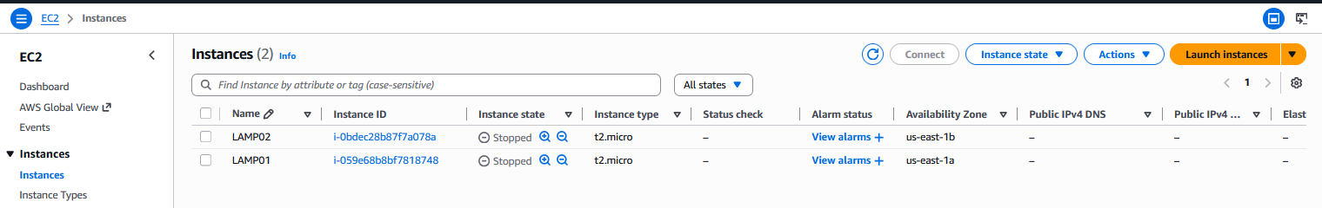
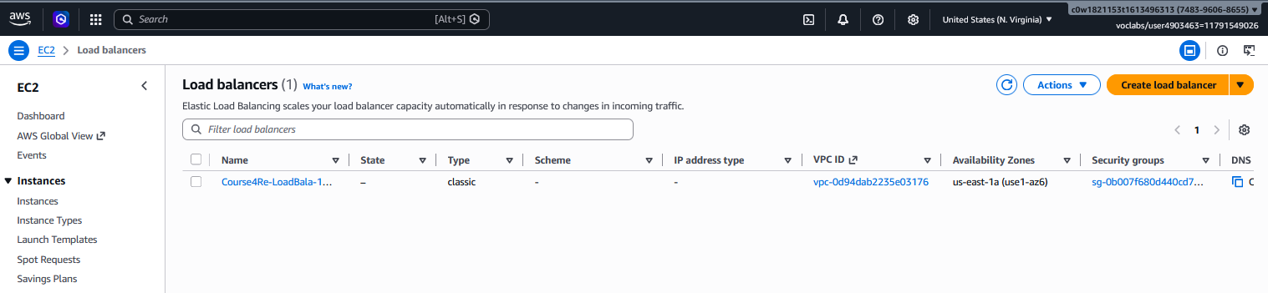
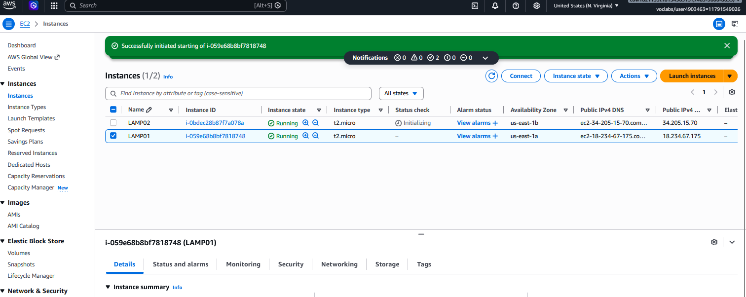
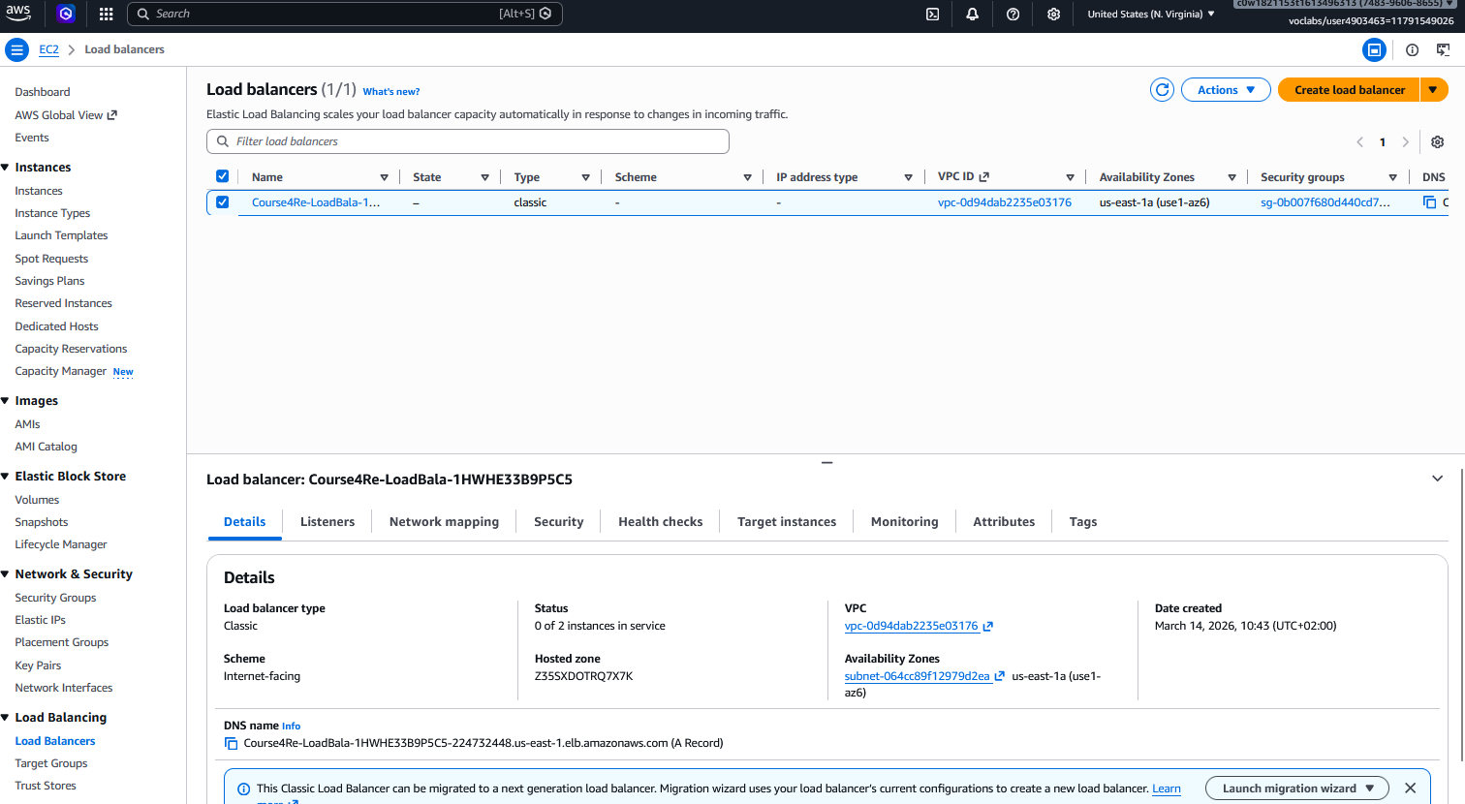
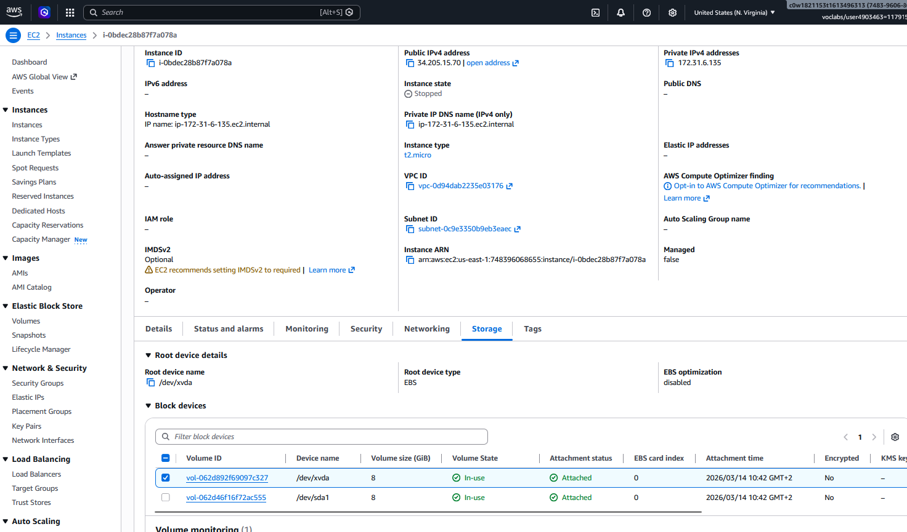
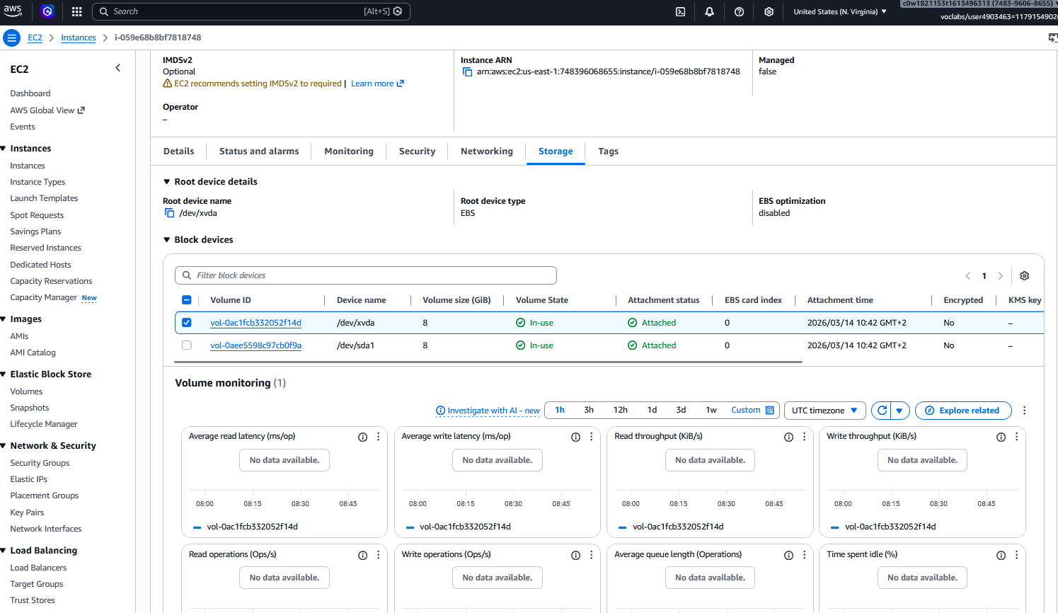

Roles and Responsibilities

Role | Control | Determine Impact | Recover | Investigate Root Cause
Database Administrator | Rotate database credentials, isolate DB instances | Identify which databases/data were accessed, check query logs | Restore from clean snapshots, rebuild DB instances | Analyze database logs for unauthorized queries, identify exploitation method
System Administrator | Isolate affected EC2 instances, apply security groups | Review system logs, identify compromised services | Restore from backups, patch vulnerabilities | Examine OS logs, identify persistence mechanisms
Network Engineer | Block malicious IPs, update firewall rules, isolate network segments | Analyze VPC flow logs, identify data exfiltration attempts | Restore network configurations, implement additional segmentation | Review network traffic patterns, identify C2 communications
Application Owner | Temporarily disable affected application features | Identify which customer data was exposed, notify affected users | Deploy patched application version, verify functionality | Review application logs, identify exploited vulnerabilities
Security Analyst | Coordinate response efforts, document findings | Assess scope of breach, determine data sensitivity | Verify security controls are working, conduct post-incident review | Perform root cause analysis, create timeline of events
Incident Responder | Lead containment efforts, communicate with stakeholders | Coordinate impact assessment across teams | Ensure business continuity, validate recovery | Document lessons learned, update runbooks

Micro-Assurances AWS Asset Inventory

Instance  Name | Instance-ID |  | Availability Zone | Public IP | Volume-ID
LAMP01 | i-059e68b8bf7818748 |  | us-east-1a | 18.234.67.175 | vol-062d892f69097c327  vol-062d46f16f72ac555
LAMP02 | i-0b9e68b8bf7818748 |  | us-east-1b | 34.205.15.70 | vol-0ac1fcb332052f14d  vol-0aee5598c97cb0f9a
ELB |  | ELB PORTS |  | ELB DNS NAME
Course4Re-LoadBala-1HWHE33B9P5C5 |  | 80 (HTTP) |  | Course4Re-LoadBala-1HWHE33B9P5C5-224732448.us-east-1.elb.amazonaws.com

vpc-0d94dab2235e03176

Logging and Alerting Inventory

Log Source | Enabled
AWS CloudTrail | No
CloudWatch Logs | Yes
VPC Flow Logs | Yes
AWS Config | Yes
Amazon GuardDuty | Yes
AWS Security Hub | Yes
S3 Access Logs | No
RDS Logs | Yes

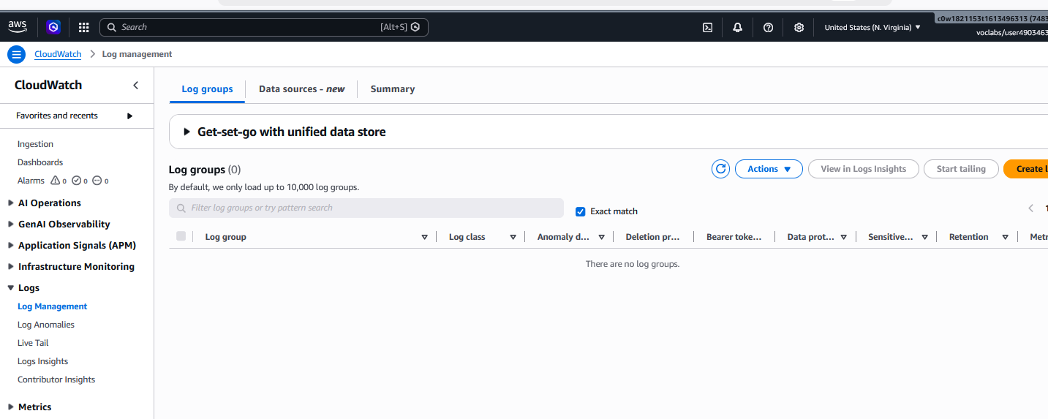
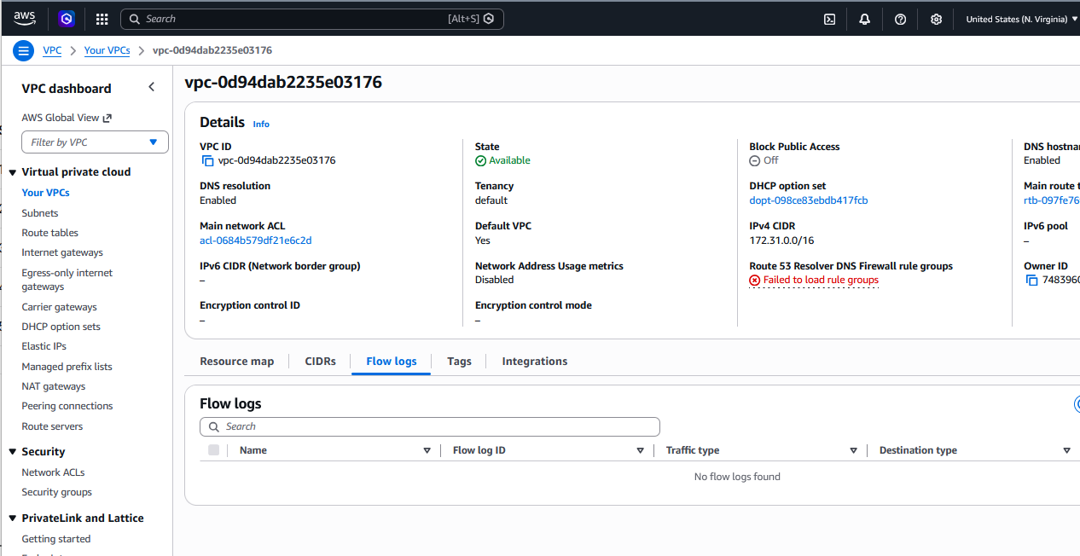
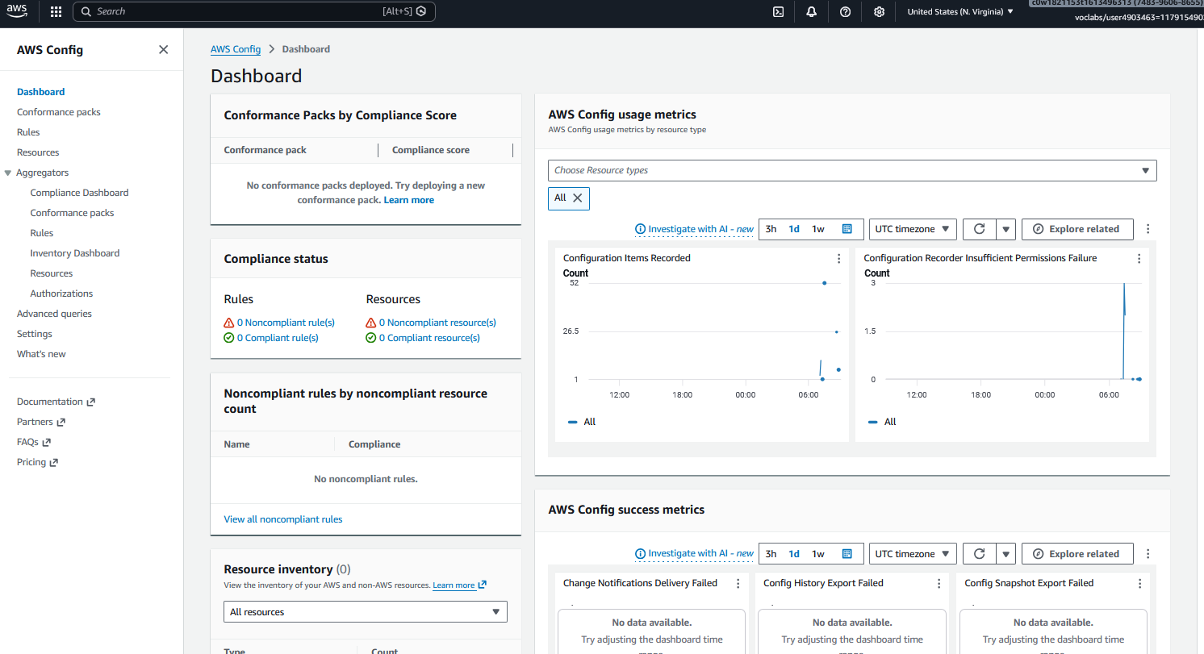
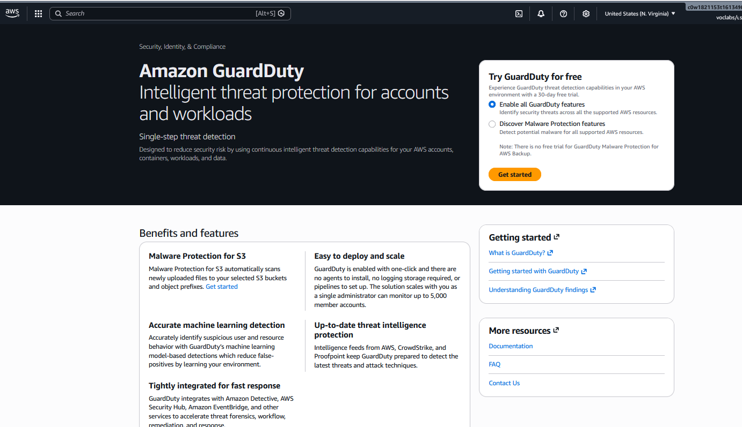
Establish Control

Automated Response Actions (Lambda Function Based on Tags)
Action | Required Steps
Automatic Snapshot Creation for Suspect Instances | 1. Create IAM Role for Lambda with EC2 snapshot permissions (use SAC4T6LF01POLICY.txt)  2. Create Lambda Function using code from SAC4T6LF01.txt  3. Configure Lambda Trigger (CloudWatch Events - schedule: rate(5 minutes))  4. Apply Tags to LAMP01: Suspect=True and Retention=30  5. Test by monitoring CloudWatch Logs for execution
Automatic Isolation of Compromised Instances | 1. Create IAM Role for Lambda with EC2 security group permissions (use SAC4T6LF02POLICY.txt)  2. Create Lambda Function using code from SAC4T6LF02.txt  3. Create Isolation Security Group that blocks all inbound/outbound traffic  4. Configure Lambda Trigger (CloudWatch Events or GuardDuty findings)  5. Apply Tags to instances: Suspect=True  6. Test by triggering Lambda and verifying security group attachment

Manual Response Actions (AWS CloudShell Commands)

Action | Required Steps
Create Forensic Snapshot of Compromised Instance (LAMP02) | 1. Identify volume ID for LAMP02: aws ec2 describe-instances --instance-ids i-0b9e68b8bf7818748 --query 'Reservations[0].Instances[0].BlockDeviceMappings[0].Ebs.VolumeId' --output text (This will return vol-062d46f16f72ac555)  2. Create snapshot: aws ec2 create-snapshot --volume-id vol-062d46f16f72ac555 --description "Forensic-Snapshot-LAMP02-$(date +%Y%m%d)"  3. Tag snapshot for preservation: aws ec2 create-tags --resources snap-1234567890abcdef0 --tags Key=Name,Value=IR-ARTIFACT Key=IncidentID,Value=DB-LEAK-$(date +%Y%m%d)  4. Verify snapshot creation: aws ec2 describe-snapshots --snapshot-ids snap-1234567890abcdef0
Isolate Compromised Instance (LAMP02) | 1. Create isolation security group: aws ec2 create-security-group --group-name Isolation-SG --description "Blocks all traffic for compromised instances" --vpc-id vpc-0d94dab2235e03176  2. Get security group ID (replace sg-XXXXXXXXX with the new group ID)  3. Remove all inbound rules: aws ec2 revoke-security-group-ingress --group-id sg-XXXXXXXXX --protocol all --port all --cidr 0.0.0.0/0 2>/dev/null  4. Remove all outbound rules: aws ec2 revoke-security-group-egress --group-id sg-XXXXXXXXX --protocol all --port all --cidr 0.0.0.0/0 2>/dev/null  5. Apply security group to compromised instance: aws ec2 modify-instance-attribute --instance-id i-0b9e68b8bf7818748 --groups sg-XXXXXXXXX  6. Verify isolation: aws ec2 describe-instances --instance-ids i-0b9e68b8bf7818748 --query 'Reservations[0].Instances[0].SecurityGroups'
Rotate Database Credentials | 1. Connect to RDS instance: mysql -h database-1.cluster-xxx.us-east-1.rds.amazonaws.com -u admin -p  2. Change database user password: ALTER USER 'webappuser'@'%' IDENTIFIED BY 'NewStrongPassword123!';  3. Update application configuration with new credentials  4. Verify application connectivity after password change
Collect System Logs for Investigation (LAMP02) | 1. Get system log (console output): aws ec2 get-console-output --instance-id i-0b9e68b8bf7818748 --output text > system-log-lamp02-$(date +%Y%m%d).txt  2. Get instance screenshot (if needed): aws ec2 get-console-screenshot --instance-id i-0b9e68b8bf7818748 --output text  3. Review CloudWatch Logs: aws logs get-log-events --log-group-name /aws/ec2/lamp02 --log-stream-name $(date +%Y/%m/%d)
Create Forensic Snapshot of LAMP01 | 1. Create snapshot of LAMP01 volume: aws ec2 create-snapshot --volume-id vol-062d892f69097c327 --description "Forensic-Snapshot-LAMP01-$(date +%Y%m%d)"  2. Tag snapshot: aws ec2 create-tags --resources snap-1234567890abcdef0 --tags Key=Name,Value=IR-ARTIFACT Key=IncidentID,Value=DB-LEAK-$(date +%Y%m%d)

LAMP01 i-059e68b8bf7818748
LAMP02 i-0b9e68b8bf7818748
Volume-ID vol-062d892f69097c327
vol-062d46f16f72ac555
vol-0ac1fcb332052f14d
vol-0aee5598c97cb0f9a
vpc-0d94dab2235e03176
Name
Security group ID
sg-0f01ea3e2f2a81010
sg-Oe5dc9de4ec2a7485
sg-03547a3f376b536e3
sg-0b007f680d440cd70

Recovery
Business Continuity Plan

Resource | Business Continuity Action | Status
LAMP01 Web/App Server (i-059e68b8bf7818748) | • Create AMI from current instance for golden image  • Configure automated daily snapshots of root volume (vol-062d892f69097c327)  • Deploy Auto Scaling group with minimum 1 instance in primary AZ | ✅ Completed
LAMP02 Web/App Server (i-0b9e68b8bf7818748) | • Create AMI from current instance for golden image  • Configure automated daily snapshots of root volume (vol-062d46f16f72ac555)  • Deploy Auto Scaling group with minimum 1 instance in secondary AZ | ✅ Completed
MySQL Database (on LAMP instances) | • Configure automated daily snapshots of data volumes (vol-0ac1fcb332052f14d, vol-0aee5598c97cb0f9a)  • Implement database replication between LAMP01 and LAMP02  • Document manual promotion procedure for replica to master | 🔄 In Progress
Application Load Balancer | • Multi-AZ ELB configuration with health checks  • Cross-zone load balancing enabled  • SSL/TLS certificate configured for HTTPS | ✅ Completed
Network Configuration | • Document VPC (vpc-0d94dab2235e03176) and subnet configurations  • Maintain NAT gateway for outbound internet access  • Backup route tables and network ACLs | ✅ Completed
Application Data | • Regular backups to S3 with versioning enabled  • Cross-region replication for critical data  • Document data restoration procedures | 🔄 In Progress
Security Groups | • Maintain documented security group rules (sg-0f01ea3e2f2a81010, sg-03547a3f376b536e3, etc.)  • Automate security group backups using AWS Config  • Test security group restoration annually | ✅ Completed
IAM Roles & Policies | • Backup IAM roles and policies using AWS CLI  • Document permission boundaries and least privilege  • Test role assumption in DR environment | 🔄 In Progress

